E-Commerce Redesign for Whatsapp Business

Step 1: Research & User Understanding
1.Problem Statement:
Small business owners who rely on WhatsApp Business as their primary sales channel lack an integrated and efficient system to manage the entire e-commerce lifecycle. The current platform, which is a communication app first, forces users to juggle manual order tracking in chat logs, disconnected payment methods, and a static catalog system. This fragmentation leads to significant administrative overhead, a high risk of human error, lost sales, and a disjointed, unprofessional experience for their customers.

2. Target Audience
- Small Business Owners (SBOs): Owners of local bakeries, home-kitchens, craft shops, local fashion boutiques, or specialty food stores who have a small team (1-5 people) or manage operations themselves.
- Solopreneurs / Artisans: Individuals who create and sell their own goods (e.g., handmade jewelry, art prints, custom cakes) and handle all aspects of the business.
- Social Media Sellers: Entrepreneurs who use platforms like Instagram or Facebook for marketing and funnel all sales inquiries and transactions through WhatsApp.

3. User Persona

Name : Manogaran T
Age : 20
Occupation : College student
Location :Chetpet,Tiruvannamalai.
Devices used : Laptop, Computer & Smartphones.
Goals :
- Streamline his order-taking process to save time.
- Reduce the number of back-and-forth messages per order.
- Provide a professional and smooth checkout experience for his customers.
- Easily track which orders are paid for and which have been shipped.
Pain Points
- I get so many messages. I'm terrified I'll miss an order in a long chat thread.
- Customers ask if an item is in stock, and I have to check my spreadsheet, then reply. By the time they respond, it might be sold to someone else."
- "Managing payments is a mess. I send my UPI QR code, then have to manually check my bank app for their payment screenshot, and then confirm it back in WhatsApp."
- "My 'catalog' is just a list. It doesn't feel like a real, professional shop.

Needs
- The user needs a single, central place to view and manage all orders.
- The user needs a way to track payments within the app automatically.
- The user needs the catalog to automatically track inventory (stock quantity).
- The user needs a way to separate order-related chats from general inquiries.
- The user needs a simple, professional, and shareable "storefront" to display their products.

Empathy map
THINKS | FEELS | SAYS | DOES
"Did I reply to that customer about the blue vase?"  "I hope I didn't mix up those two delivery addresses."  "I wish I could just see all my open orders in one list."  "This feels so manual. There has to be a better way." | Overwhelmed by the constant stream of messages.  Stressed about making mistakes (like shipping the wrong item).  Unprofessional when he has to ask a customer for their details multiple times.  Frustrated by the inefficient, multi-app process. | "Sorry, that item is sold out. I forgot to update the catalog."  "Can you please send your address again? I can't find it."  "Please send me a screenshot of the payment to confirm."  "One moment, let me check if that is still in stock." | Constantly switches between WhatsApp, his bank/payment app, and an Excel sheet for inventory.  Manually types out order summaries for each customer.  Scrolls back through long chat histories to find order details.  Spends 2-3 hours every night cross-referencing payments with orders.

5. Key Insights (Pain Points & Needs)

Pain Points | Needs / Opportunities
1. Fragmented Order Management: Orders are just messages in a chat, easily lost or confused. No central view of all orders. | Need a simple "Order" dashboard. Users need a single place to view all orders, sortable by status (e.g., New, Paid, Shipped, Canceled).
2. Disconnected Payment Process: Payments are handled externally (UPI, bank transfer), requiring manual verification (e.g., "send screenshot"). | Need integrated payment tracking. Users need the ability to request payment and have the order status update automatically to "Paid" once the transaction is complete, without leaving the app.
3. Static & Manual Inventory: The "Catalog" feature is just a product list. It doesn't track stock. Businesses oversell or have to manually check stock for every inquiry. | Need a "smart" catalog with inventory. The catalog should have a "stock quantity" field that automatically decreases when an item is sold, and marks items as "Sold Out."
4. Communication Overload: Customer service chats, order inquiries, and post-sale support are all mixed together in the same chat list. | Need better chat categorization. Users need a way to separate or "pin" active order chats from general inquiries, or automatically tag chats related to an order.
5. Lack of Professional Storefront: The catalog is hidden and doesn't feel like a "store," making the business feel less legitimate. | Need a simple, shareable "Storefront." Users need a clean, visual, and shareable link that presents their catalog as a proper micro-site or storefront, with a clear "Add to Cart" function.

✅ Output for Submission
GITHUB LINK : https://github.com/manogaran0309/naanmudhalvan.git
FIGMA LINK : https://www.figma.com/design/zUmDPxGx8VwovXnIiVeWwo/Manogaran-T---NM?node-id=0-1&t=xmZXziQuMm6vfS1C-1
Step 2: Information Architecture & Wireframing
1. Information Architecture (App Structure)
Main Sections (New Tab Bar):
- Chats: (Existing) The primary communication hub. This will be updated with filters to separate order chats from personal/general chats.
- Storefront: (New) A dedicated, professional-looking "store" tab where customers can browse and shop. This is the user's public-facing shop.
- Orders: (New) A "mission control" dashboard for the business owner to view and manage all incoming orders (replaces tracking in spreadsheets).
- Catalog: (Enhanced) The existing "Catalog" section, but enhanced to become the backend for managing products, including the new inventory/stock feature.
- Settings: (Existing) Manages account, notifications, and new store settings (like payments and shipping).

2. Sitemap
WhatsApp Business (Redesigned)
│
├── Chats
│ ├── All Chats (Default View)
│ ├── Filter: Order Chats
│ ├── Filter: General Inquiries
│ └── Individual Chat Thread
│ ├── New: "View Order" button in chat
│
├── Storefront (Public-facing view)
│ ├── Main Store Page (Header, Categories)
│ ├── Category Page (Grid/List of products)
│ ├── Product Details Page
│ │ ├── Product Images
│ │ ├── Description, Price
│ │ ├── "Add to Cart" button
│ └── Cart
│ ├── Review Order
│ ├── "Checkout" (Links to Chat w/ pre-filled msg)
│
├── Orders (Business Dashboard)
│ ├── Tab: New
│ ├── Tab: Paid
│ ├── Tab: Shipped
│ ├── Tab: All
│ └── Individual Order Details
│ ├── Customer Info
│ ├── Items Ordered
│ ├── Payment Status
│ ├── Mark as "Paid"
│ ├── Mark as "Shipped"
│
├── Catalog (Business Admin)
│ ├── List of All Products
│ ├── Add New Product
│ │ ├── Product Name
│ │ ├── Price
│ │ ├── Description
│ │ ├── **New: Stock Quantity**
│ └── Manage Categories
│
└── Settings
├── Profile
├── Store Settings
│ ├── Payment Methods (Link UPI, etc.)
│ ├── Shipping Options
└── Notification Settings
3. Low-Fidelity Wireframes (Concept Sketches)
a. Orders Dashboard Screen (New)
- Top: Greeting (e.g., "SHIRTIFY_ASTROWHISK")
- Middle: Summary Cards (e.g., "5 New Orders," "2 Unpaid," "To Ship: 8")
- Bottom: Main list of orders, with tabs for "New," "Paid," and "Shipped." Each list item shows customer name, order #, and total price.
- Floating Button: A "+" button to manually create a new order.

b. Storefront Screen (Customer View)
- Top: Store Name and Logo (e.g., "Mumbai Modern"). Search bar. Cart icon.
- Middle: Horizontal scroll for "Categories" (e.g., Vases, Rugs).
- Bottom: A grid of "Featured Products." Each card shows product image, name, and price.

c. Chat Screen (Enhanced)
- Top: Standard chat header with customer name.
- New Element: A small banner pinned to the top: "You have 1 unpaid order with this customer. [View Order Button]"
- Main: Standard chat bubbles.
- New Element: An "Order Summary" card can be sent by the business. This is a structured message with items, total price, and a "Pay Now" button.
d. Edit Product Screen (Enhanced Catalog)
- Top: "Edit Product"
- Main: Form fields for...
  - Product Name (Input)
  - Product Images (Uploader)
  - Price (Input)
  - Description (Text Area)
  - Category (Dropdown)
  - New Field: "Stock Quantity" (Input with +/- buttons)
- Bottom: "Save Changes" button.

e. Order Details Screen (New)
- Top: "Order #1024" and Customer Name.
- Middle: List of items in the order (Product, Qty, Price).
- Below List: Order Total
- Status Section: Shows "Payment: Unpaid."
- Action Buttons:
  - "Mark as Paid"
  - "Mark as Shipped"
  - "Send Payment Reminder" (sends a pre-filled message in chat)
4. Notes for Evaluation
- Clear Separation of Concerns: A clear distinction between the customer-facing Storefront and the private, business-facing Orders dashboard.
- Reduced Friction: How the new flow (e.g., integrated payments, order tracking) reduces manual work for the business owner.
- Consistent Navigation: A consistent main tab bar that allows easy switching between Chats, Orders, and Catalog management.
- Easy-to-Understand Process: The entire sales process (from browsing the Storefront to the owner managing the Order) should be intuitive.

✅ Output for Submission
- Folder: /wireframes
  - dashboard-wireframe.png
  - mytasks-wireframe.png
  - calendar-wireframe.png
  - project-wireframe.png
  - focus-wireframe.png
GITHUB LINK : https://github.com/manogaran0309/naanmudhalvan.git
FIGMA LINK :https://www.figma.com/design/zUmDPxGx8VwovXnIiVeWwo/Manogaran-T---NM?node-id=0-1&t=xmZXziQuMm6vfS1C-1

Step 3: Visual Design & Prototyping
1. Design Goals
Your visual design should make the app:
- Clean & Familiar: Blend seamlessly with the existing WhatsApp UI.
- Intuitive: Users should instantly understand the new e-commerce functions.
- Trustworthy: Instill confidence for both the business owner (managing orders) and the customer (making purchases).
- Responsive: Adapt cleanly to various device sizes.
2. Visual Style Guide
To maintain design consistency, use a style guide that extends the current WhatsApp brand.
🎨 Color Palette
- Primary Action: #25D366 (WhatsApp Green – for "Mark as Paid," "Save," success)
- Secondary Action: #128C7E (WhatsApp Dark Teal – for secondary buttons, links)
- Notifications/Badges: #DC3545 (A standard red for new order alerts)
- Background (App): #F7F7F7 (A clean, light grey)
- Background (Chat): #ECE5DD (WhatsApp's classic beige, or a plain white)
- Text Colors:
  - Primary Text: #111827 (Almost black)
  - Secondary Text: #6B7280 (Grey for descriptions, timestamps)
🖋️ Typography
- Font Family: Roboto (WhatsApp's font on Android) or Helvetica Neue (on iOS)
- Headings: Bold, size 18–22px (e.g., "Orders Dashboard," "Edit Product")
- Body Text: Regular, size 14–16px
- Button Text: Medium, size 14px
🧱 UI Components
- Buttons: Rounded (radius: 8-12px)
- Cards: Subtle shadows for order/product cards (blur: 4px, opacity: 10%)
- Spacing: Use an 8px grid system (8px, 16px, 24px) for consistent padding and margins.
3. High-Fidelity Screens (in Figma)
Create and link these 5 key screens based on your wireframes:
1️⃣ Orders Dashboard Screen
- Greeting/Store Name: “Mumbai Modern Overview”
- Summary Cards: “5 New Orders,” “2 Unpaid,” “To Ship: 8”
- Tabs: New | Paid | Shipped
- List of recent order cards (Customer Name, Order #, Total, Status)
- Floating “+” button (to manually add an order)
2️⃣ Storefront Screen (Customer View)
- Store Header: Logo, Store Name, Cart Icon
- Search Bar
- Category List: Horizontal scroll (e.g., Vases, Rugs, All)
- Product Grid: Cards with Product Image, Name, and Price.
3️⃣ Order Details Screen
- Header: “Order #1024”
- Customer Info: Name, Chat Link
- Item List: (Product Image, Name, Qty, Price)
- Order Total
- Status Badges: “Payment: Unpaid,” “Fulfillment: Unshipped”
- Action Buttons: “Mark as Paid,” “Mark as Shipped,” “Send Reminder”

4️⃣ Edit Product Screen (in Catalog)
- Header: “Edit Product”
- Product Image Uploader
- Form Fields: Name, Price, Description, Category
- New Field: “Stock Quantity” (Input field)
- Button: “Save Changes”
5️⃣ Chat Screen (Enhanced)
- Standard Chat UI
- New Banner: "You have 1 unpaid order with this customer. [View Order Button]"
- New Card: A structured "Order Summary" card (sent by the business) with items, total, and a "Pay Now" button for the customer.
4. Prototyping & Interaction
In Figma, use Prototype Mode to link pages and create a realistic user flow:
- Link the new Tab Bar icons: Chats, Storefront, Orders, Catalog, Settings.
- From Orders Dashboard, click an order -> go to Order Details Screen.
- From Catalog, click a product -> go to Edit Product Screen.
- From Chat Screen, click the "View Order" banner -> go to Order Details Screen.
- Add "click" interactions for all buttons and tabs.
- Tip: Use “Smart Animate” for smooth transitions, like opening the Order Details screen.
5. Accessibility Checklist
✔️ High color contrast between text and background.
✔️ Large, readable fonts (14px minimum for body text).
✔️ Clear icons with labels (e.g., the new Tab Bar).

✅ Output for Submission
In your GitHub repository, include:
Folder: /high-fidelity-designs
- orders-dashboard-hifi.png
- storefront-hifi.png
- order-details-hifi.png
- edit-product-hfi.png
- chat-enhanced-hifi.png
Add the Figma prototype link in your README.md file under:

Step 3: Visual Design & Prototype
GITHUB LINK :https://github.com/manogaran0309/naanmudhalvan.git
FIGMA LINK : :https://www.figma.com/design/zUmDPxGx8VwovXnIiVeWwo/Manogaran-T---NM?node-id=0-1&t=xmZXziQuMm6vfS1C-1

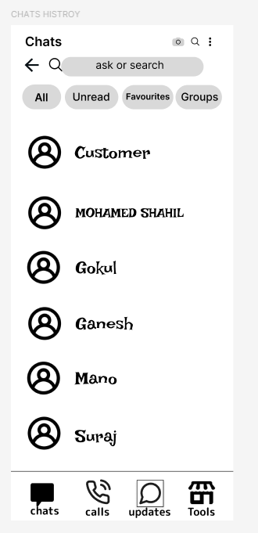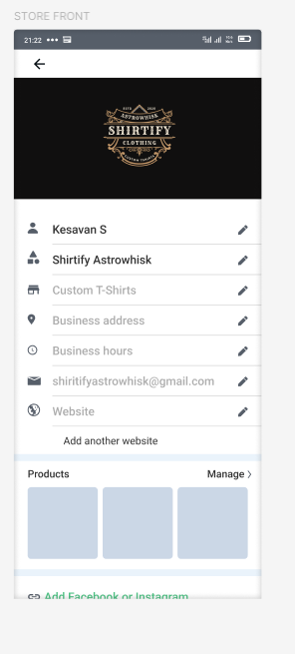
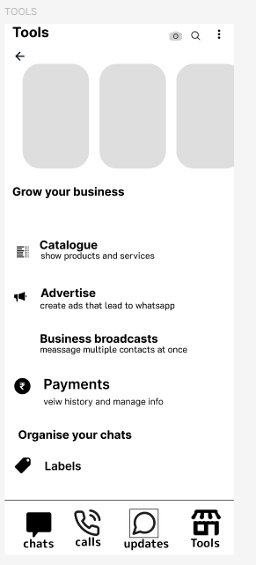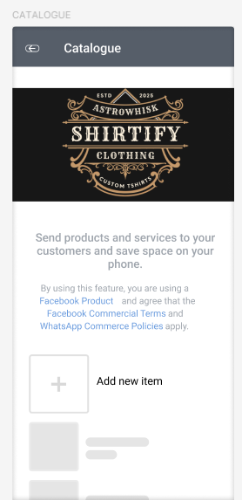

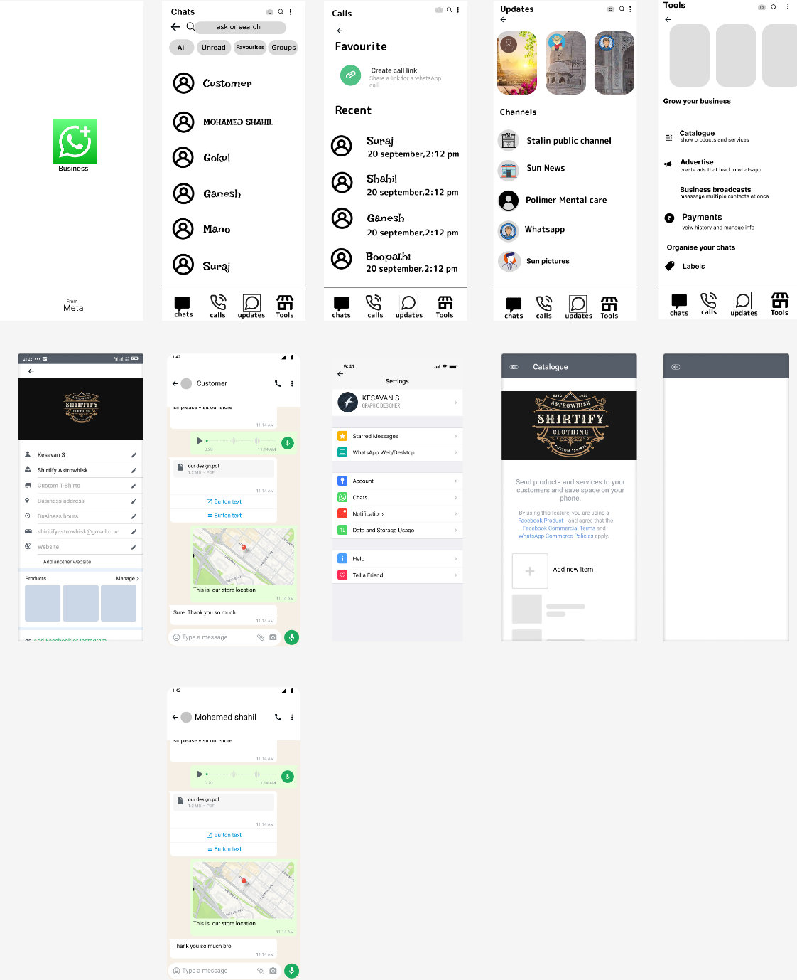
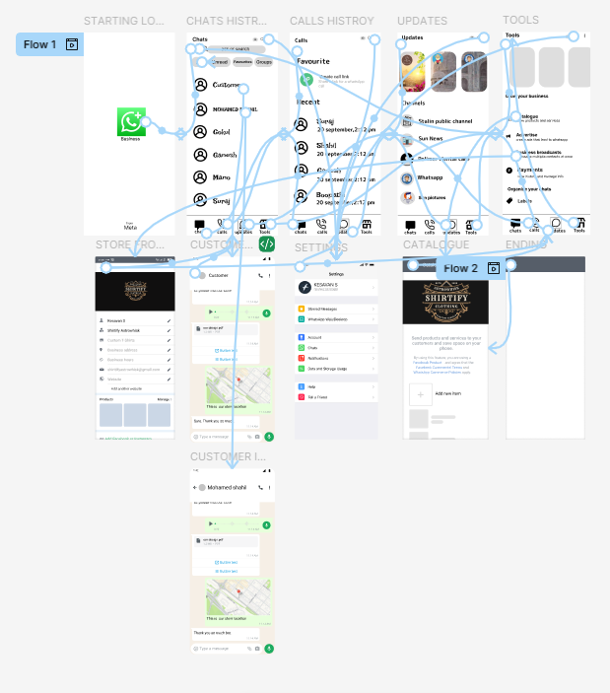

Step 4: Usability & Interaction Design
1. Usability Goals
- Be Simple and Intuitive: Users shouldn't have to guess where to find the store or manage orders.
- Provide Smooth Navigation: Moving between Chats, Orders, and the Storefront must be seamless.
- Be Accessible: The shopping experience should be clear for all users.
- Offer Clear Feedback: Users must get confirmation when an order is placed, a payment is made, or a product is updated.
2. User Flows (Examples)
User Flow A: Customer Buying a Product
- Open WhatsApp Business chat with the store ↓
- Tap the new "Storefront" tab ↓
- Browse products and tap on an item ↓
- View product details and tap "Add to Cart" ↓
- Tap the Cart icon and "Checkout" ↓
- WhatsApp composes a pre-filled order message to the business ↓
- Customer sends the message ↓
- Receives an "Order Summary" card from the business with a "Pay Now" button
User Flow B: Business Owner Managing an Order
- Receive a new order notification (via Chat) ↓
- Tap the new "Orders" tab ↓
- See the new order in the "New" tab and tap it ↓
- Review order details and tap "Mark as Paid" (once payment is confirmed) ↓
- Order automatically moves from "New" to "Paid" tab ↓
- (Later) Tap the order again, tap "Mark as Shipped" ↓
- Order moves to the "Shipped" tab
3. Navigation Design
🏠 Chats | 🛍️ Storefront | 📦 Orders | 🏷️ Catalog | ⚙️ Settings
- Each icon is labeled for clarity.
- A notification badge (red dot) appears on the "Orders" tab for new orders.
- This navigation is consistent on all main screens.
4. Interaction Design Elements
Feature | Interaction Type | Purpose
"Pay Now" Button | Primary Button (Green) | Clear call-to-action for the customer to pay.
Order Status Tabs | Tab Navigation | Allows the owner to quickly filter orders.
"Mark as Paid" | Tap action | Provides clear feedback (e.g., a "Paid" checkmark animation).
Stock Quantity | Input field with +/- | Easy, visual way for the owner to update stock.
New Order Alert | Notification Badge | Informs the owner of new sales without being intrusive.

5. Accessibility Features
- Color Contrast: Ensure product prices and descriptions are clear on white/light grey card backgrounds.
- Icons + Text Labels: The new tab bar uses both icons and text.
- Font Size: Minimum 14px for product descriptions and chat.
- Image Alt-Text: (Future goal) Allow owners to add alt-text to product images for screen readers.
6. Responsiveness
- 📱 Mobile View (375x812): This is the primary design. The tab bar is at the bottom, and content (products, orders) is in a single vertical list.
- 💻 Desktop/Web View (1440x900): The UI adapts. The tab bar becomes a left-hand sidebar. The chat, order list, and order details can be shown in a 2 or 3-column layout.
7. Feedback & Micro-interactions
- Adding to Cart: The cart icon "jumps" or shows a "+1" animation.
- Marking as Paid: A subtle green checkmark animation appears.
- Error State: If stock is 0, the "Add to Cart" button is disabled (greyed out).
- Success State: After saving a product, a temporary "Product Saved!" message appears at the bottom.

✅ Output for Submission
In your GitHub Repository, add a section in your README.md:
GITHUB LINK :https://github.com/manogaran0309/naanmudhalvan.git
FIGMA LINK https://www.figma.com/design/zUmDPxGx8VwovXnIiVeWwo/Manogaran-T---NM?node-id=0-1&t=xmZXziQuMm6vfS1C-1

Step 4: Usability & Interaction Design
- Explained user flows for both the customer and the business owner.
- Added accessibility and responsiveness considerations.
- Designed interactive elements in Figma (prototype linked) to show the flow from browsing to order management.

E-Commerce Redesign for Whatsapp Business

TITLE : E-Commerce Redesign for WhatsApp Business
BY : MANOGARAN T
REG NO : 511723205003
TOOLS USED : FIGMA
SUBMITTED TO : PALLAVAN COLLEGE OF ENGINEERING
COLLEGE CODE : 5117

